UNIT 1: WRITE
I/ Vocabulary :
- curly hair (n): tóc quăn
- straight hair (n): tóc thẳng
- heavy (v): đô, nặng ( cao to)
- slim (adj): mảnh khảnh
- thin ( adj): gầy, mỏng
II/ Read the information about Tam
a) What does he look like ?
- tall, thin, and has short hair.
b) Where does he live ?
- 26 Tran Phu streets
c) Who does he live with ?
- parents, elder brother
d) Who are his friends ?
Ba and Bao.

III. Fill in a similar form for your partner

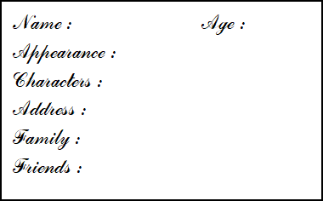

IV/ WHILE WRITING:

His name is ………and he is ….years old. He lives at …. with …… He’s …… and has……. He is…… His best friends are ….

